**Armani Prive**

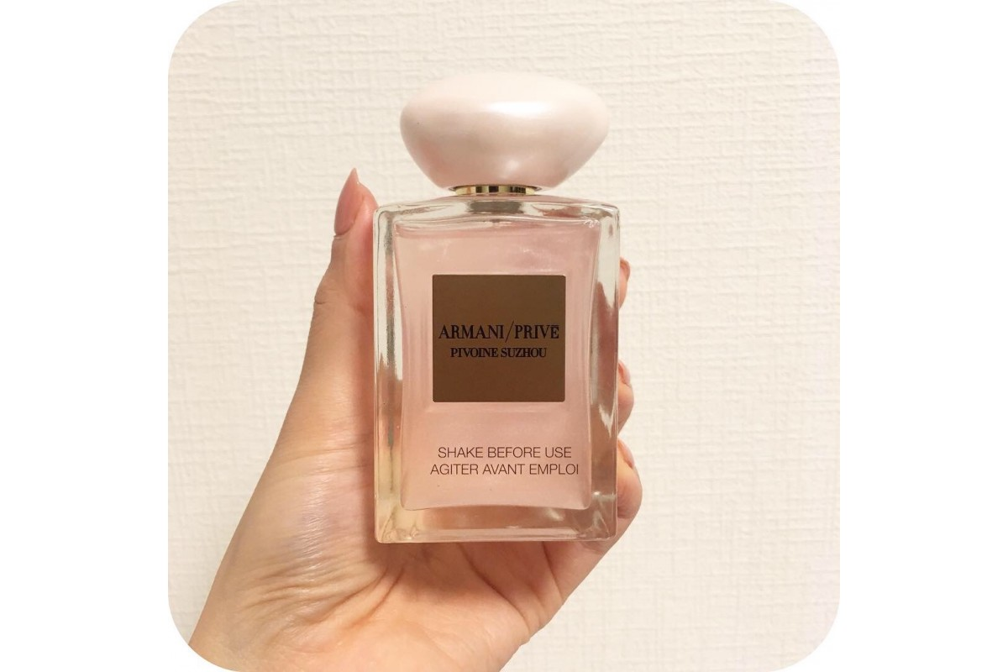The exclusive Armani/Privé creations, encased in exquisite, distinctive bottles, describe and celebrate experiences, memories and picturesque landscapes of the world, through an unforgettable, olfactory journey of exploration.

Each fragrance stimulates a state of mind and creates an atmosphere inspired by the arts and traditions of faraway places.